**OUTPUT ON TARGET CONSOLE:**

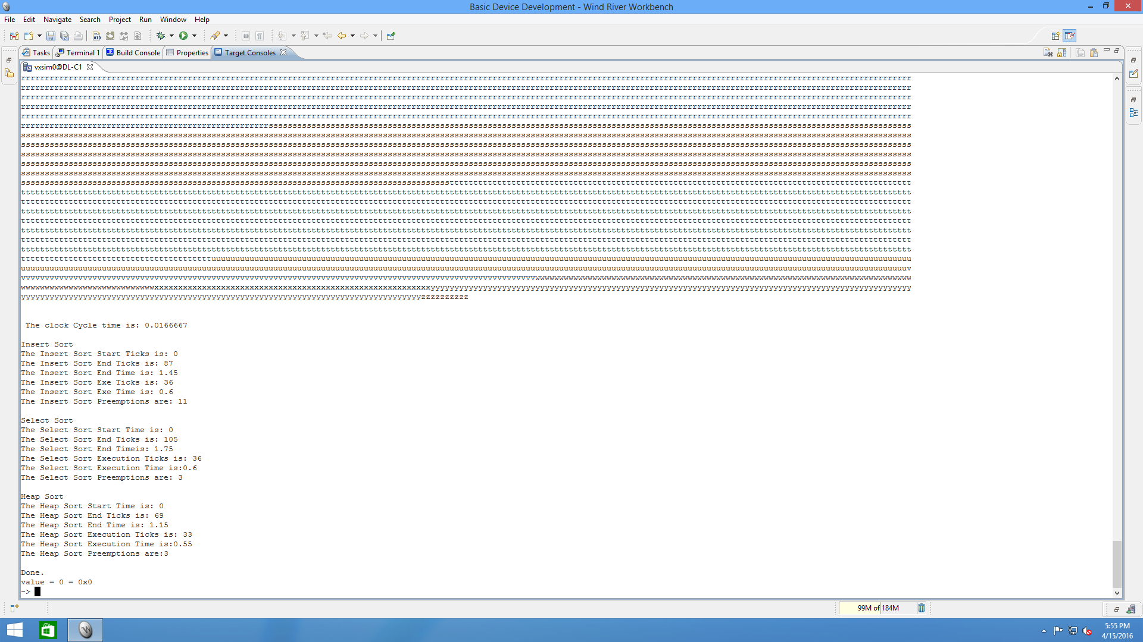

**RESULTS: (OUTPUT)**

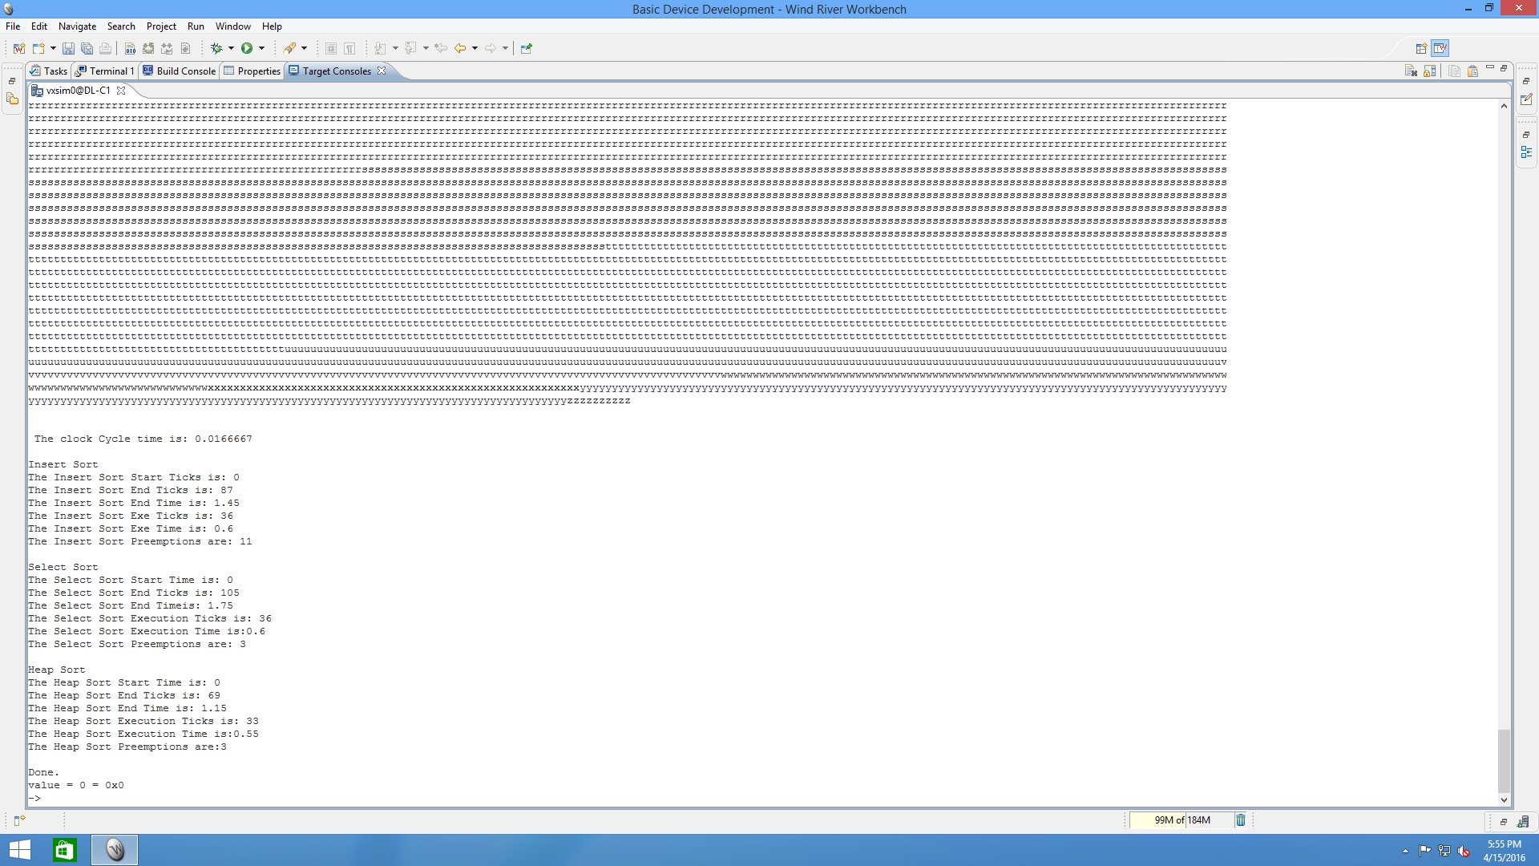

Now, we use the File System viewer, we observe the following Event Log (graph):

